**Sql code Case study**

-- Employee Table

create table employee (

employeeid int primary key,

name varchar(50),

departmentid int,

salary int,

hiredate date

);

drop table employee

-- Department Table

create table department (

departmentid int primary key,

departmentname varchar(50)

);

-- Performance Table

create table performance (

performanceid int primary key,

employeeid int,

reviewdate date,

score int,

foreign key (employeeid) references employee(employeeid)

);

-- Departments

insert into department values

(1, 'HR'),

(2, 'Engineering'),

(3, 'Marketing');

-- Employees

insert into employee values

(1, 'Arjun', 2, 75000, '2023-02-15'),

(2, 'Meena', 1, 60000, '2024-07-01'),

(3, 'Ravi', 2, 85000, '2024-03-10'),

(4, 'Sneha', 3, 72000, '2022-09-05'),

(5, 'Kumar', 1, 90000, '2024-08-20');

-- Performance

insert into performance values

(101, 1, '2025-01-10', 88),

(102, 2, '2025-02-14', 92),

(103, 3, '2025-01-30', 95),

(104, 4, '2024-11-20', 78),

(105, 5, '2025-01-15', 85);

select * from employee

select * from department

select * from performance



--Top 3 score

select top 3

e.name,

d.departmentname,

p.score,

p.reviewdate

from performance p

join employee e on p.employeeid = e.employeeid

join department d on e.departmentid = d.departmentid

order by p.score desc;

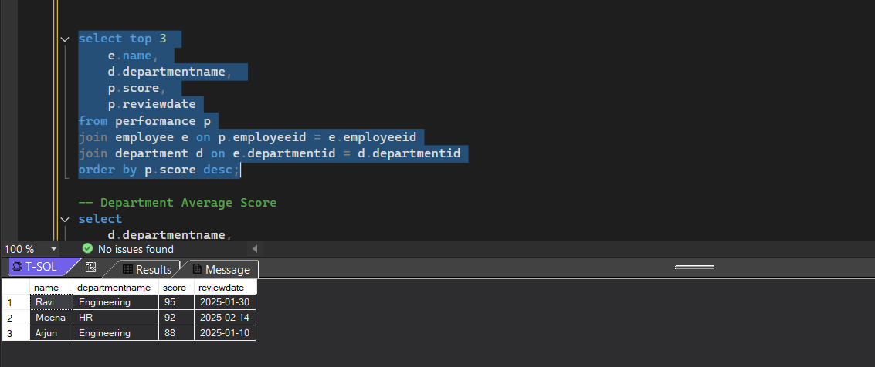

-- Department Average Score

select

d.departmentname,

avg(p.score) as avg_score

from performance p

join employee e on p.employeeid = e.employeeid

join department d on e.departmentid = d.departmentid

group by d.departmentname;

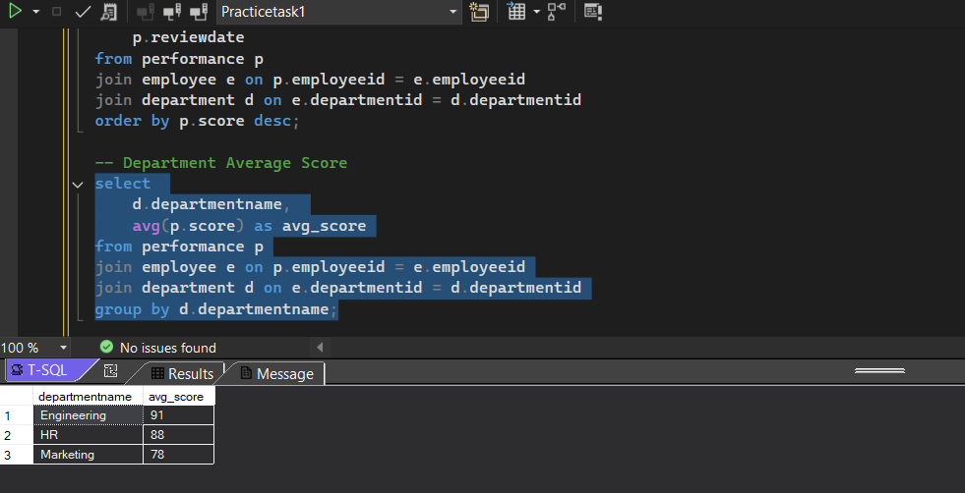

--Salary vs Score (Salary > avg and Score > 80)

select

e.name,

e.salary,

p.score

from performance p

join employee e on p.employeeid = e.employeeid

where e.salary > (select avg(salary) from employee)

and p.score > 80;

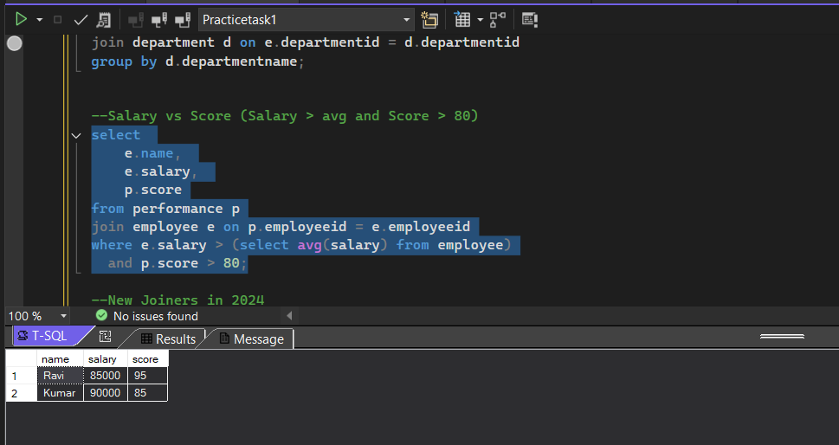

--New Joiners in 2024

select * from employee

where hiredate >= '2024-01-01' and hiredate <= '2024-12-31';

